Lesson 1 – Number Sequences
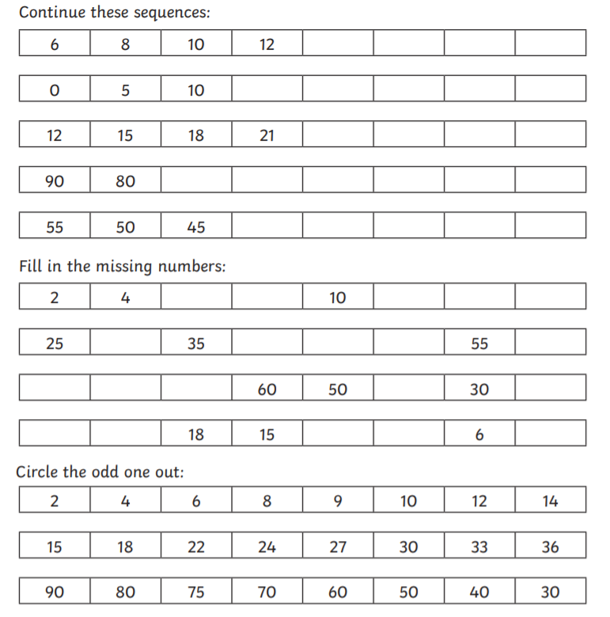

Lesson 1 – Number Sequences (harder)


